|  |  |
| --- | --- |
| VISUAL | Information  Retrieval |

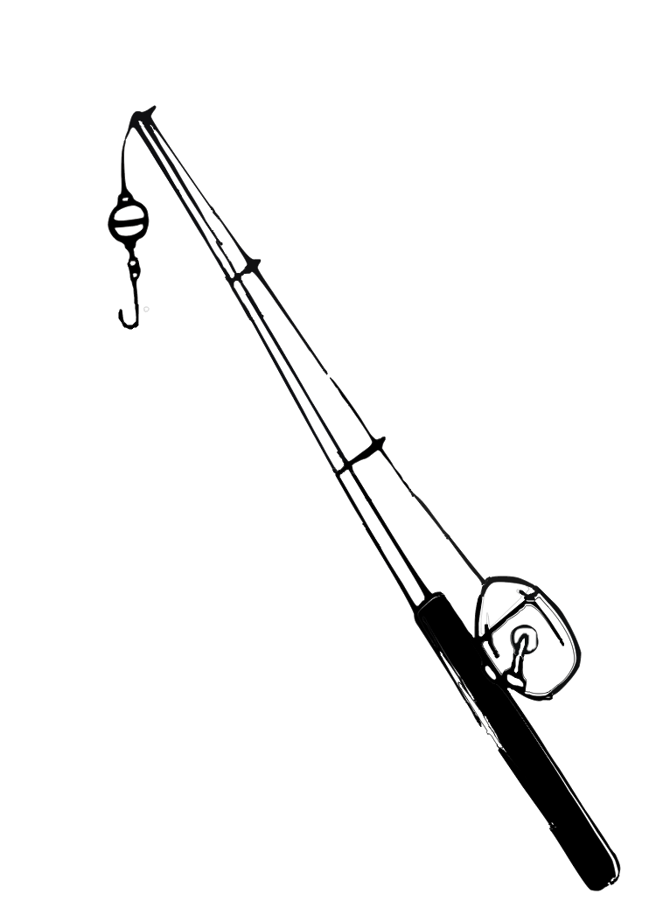

COMS W4735: Visual Interfaces to Computers

Assignment 2

due: 3/17/2015

Nina Baculinao

uni: nb2406

Table of Contents

Introduction 2

Color Measure 3

Bin Size 3

Black Threshold 3

Results 3

Gross Texture Matching 18

Texture Measure 18

Bin Size 18

Black Threshold 18

Results 18

Combine Similarities, and Cluster 19

Similarity Measure 33

Complete Link vs. Single Link Clustering 33

Results 33

Creative Step 33

Performance Measure 33

Friend Results 33

System Results 33

Code Listing 33

visret.py 33

performance.py 33

Appendix: User Studies 34

# Introduction

The goal of the Visual Information Retrieval system is to explore different ways of deciding the degree of similarities between actual images. It primarily looks at color, texture, similarity as a linear sum of ratios between the two, and clustering. Finally, the system is evaluated against the more intelligent baseline of human judgment to see how it performs.

Images analyzed in this project had the following properties:

* PPM format (versus lossier JPEG versions)
* 89 x 60 pixels
* 01-40 numbering sequence

Hardware and library specifications of this project are as follows:

* MacBook Air 11 inch running on OSX Yosemite
* Python Standard Library 2.7.9
* OpenCV with a Python binding, v2.4.10.1
* NumPy 1.9.1
* Matplotlib 1.4.2

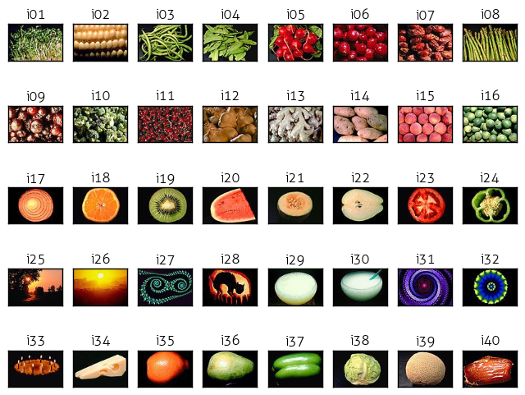

*Figure 1.* All the images analyzed by the system

*Note:* the display on the previous page was generated with matplotlib using the following code snippet. While the learning curve for matplotlib is a bit steep, its ability to plot images and graph figures along various axes, rows and columns was very useful.

**def** display_all(images, titles):

plt.rcParams['font.family']='Aller Light'

**for** i **in** xrange(NUM_IM):

plt.subplot(5,8,i+1),plt.imshow(cv2.cvtColor(images[i], cv2.COLOR_BGR2RGB))

plt.title(titles[i], size=12)

plt.xticks([]),plt.yticks([])

title = './all_im.png'

plt.savefig(title, bbox_inches='tight')

**print** title

Gross Color Matching

## Overview

The algorithm to compare images strictly on their total color distribution is described in broad steps directly below, and in more detail following this general description.

1. For each image in the directory:
   1. Load the image with OpenCV2 (and append to a list)
   2. Generate a color histogram for the image (and append to a list)
   3. *Optional*: Visualize the histogram as a bar graph (and append to a list)
2. Calculate the distance between every image pair (and store in a lookup dictionary)
   1. Use the histograms values of each image pair to determine the L1 norm
3. For each image:
   1. Determine the three images *most like it* and the three images *most unlike it* in terms of color distribution
   2. Display the septuples: original, three alike, three unalike
4. Determine group of four *most alike* images and group of four *most unalike* images
   1. Display the two groups of four: most alike, most unalike

## Color Histogram

The histogram calculations are computed without the aid of any black box algorithms. While OpenCV does have the cv2.compareHist function and SciPy also comes with its own distance metrics, implementing a 3D color histogram is actually quite simple, as can be seen in my code fragment below:

**def** color_histogram(image, title):

*'''*

*Calculate the 3D color histogram of an image by counting the number*

*of RGB values in a set number of bins*

*image -- pre-loaded image using cv2.imread function*

*title -- image title*

*(optional: visualize the histogram as a bar graph)*

*'''*

colors = []

h = len(image)

w = len(image[0])

*# Create a 3D array - if BINS is 8, there are 8^3 = 512 total bins*

hist = np.zeros(shape=(BINS, BINS, BINS))

*# Traverse each pixel in the image matrix and increment the appropriate*

*# hist[r_bin][g_bin][b_bin] - we know which one by floor dividing the*

*# original RGB values / BIN_SIZE*

**for** i **in** xrange(h):

**for** j **in** xrange(w):

pixel = image[i][j]

*# If the pixel is below the black threshold, do not count it*

*# Also note: pixel[i] is descending since OpenCV loads BGR*

**if** pixel[0] > BLK_THRESH **and** pixel[1] > BLK_THRESH \

**and** pixel[2] > BLK_THRESH:

r_bin = pixel[2] / BIN_SIZE

g_bin = pixel[1] / BIN_SIZE

b_bin = pixel[0] / BIN_SIZE

hist[r_bin][g_bin][b_bin] += 1

*# Generate list of color keys for visualization*

**if** (r_bin,g_bin,b_bin) **not** **in** colors:

colors.append( (r_bin,g_bin,b_bin) )

*# plot = visualize_chist(image, hist, colors, title)*

*# return plot, hist*

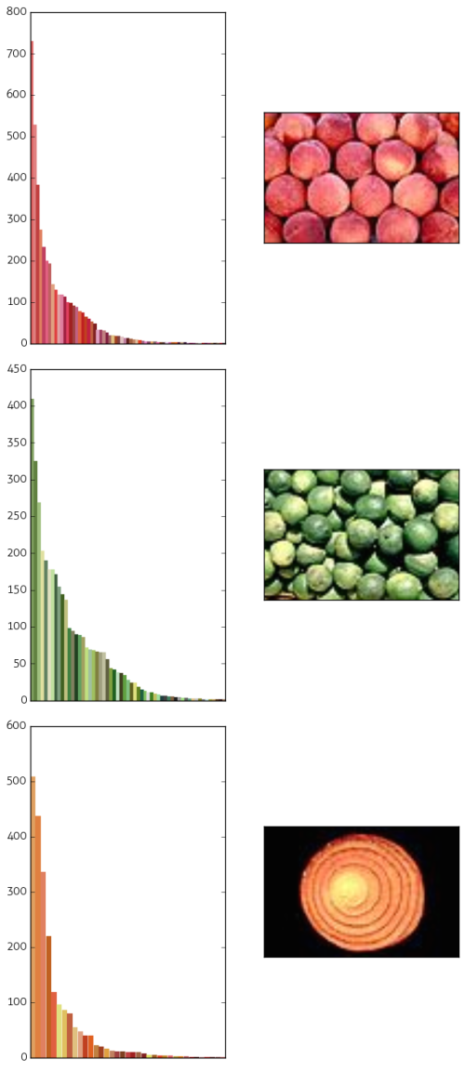 **return** hist

## Important decisions in this step included selection of the **BINS** and **BLK_THRESH**, which I will discuss in the immediately following subsection.

## You might notice that the invocation for the **visualize_chist** function is commented out. That is because writing and generating every single figure takes about a little bit of extra runtime, and once I saved the images to a folder, I do not really need to produce the bar graphs again again. The **visualize_chist** function invokes matplotlib to plot a bar graph for the histogram, so it’s a lot of boilerplate, but the key to it lies in this line:

colors = sorted(colors, key=**lambda** c:

-hist[(c[0])][(c[1])][(c[2])])

## **colors** is the list of RGB color tuples from the **color_histogram** method, and this line re-sorts it from the highest count for that tuple in the histogram to the lowest count. Then it uses the following helper function:

**def** hexencode(rgb, factor):

*"""Convert RGB tuple to hexadecimal color code."""*

r = rgb[0]*factor

g = rgb[1]*factor

b = rgb[2]*factor

**return** '#**%02x%02x%02x**' % (r,g,b)

## to create the color hex string for displaying the bar graph. Example output can be seen on the right.

*Figure 2.* Histograms for images: i15, i16, and i17. Note that black pixels are not counted.

## Bin Size and Black Threshold

|  |  |  |  |  |  |  |  |  |  |
| --- | --- | --- | --- | --- | --- | --- | --- | --- | --- |
| R: 0  G: 0  B: 0 | 10  10  10 | 20  20  20 | 30  30  30 | 40  40  40 | 50  50  50 | 60  60  60 | 70  70  70 | 80  80  80 | 90  90  90 |

*Figure 3.* Histograms for images: i15, i16, and i17. Note that black pixels are not counted.

COL_RANGE = 256

BLK_THRESH = 40

BINS = 8

BIN_SIZE = int(COL_RANGE/BINS)

BLK_THRESH = 40

**if** pixel[0] > BLK_THRESH **and** pixel[1] > BLK_THRESH **and** pixel[2] > BLK_THRESH:

DO THIS PART VERY IMPORTANT

* After printing out the numpy array and surveying the black, determine with my human eyes as a baseline that values under 40, 40, 40 are hard to discern as other than black
* Check original pixel values before adding to histogram to check whether all RGB values are under 40
* Possible influence for my low sensitivity to black color may be due to the fact that I like to do computer work with flux on and low brightness
* Generated a few color histograms and got the same results whether 8 bins or more, therefore decided 8 was enough
* Color bar – you could see the wider range of colors
* But same results for final seven tuple
* Found it more intuitive to work with distance than similarities, and look for shortest distances
* Use similarity = 1 – distance for the septuple captions of similarity
* To calculate the relative similarity or distances between a pair of images, I calculated the L1 color norm

L1_norm = ∑ (differences) / ∑ (pixel count)

**def** l1_color_norm(h1, h2):

diff = 0

total = 0

**for** r **in** xrange(0, BINS):

**for** g **in** xrange(0, BINS):

**for** b **in** range(0, BINS):

diff += abs(h1[r][g][b] - h2[r][g][b])

total += h1[r][g][b] + h2[r][g][b]

l1_norm = diff / 2.0 / total

similarity = 1 - l1_norm

**return** l1_norm

**def** calc_cdistance(chists):

chist_dis = {}

**for** i **in** xrange(NUM_IM):

**for** j **in** xrange(i, NUM_IM):

**if** (i,j) **not** **in** chist_dis:

d = l1_color_norm(chists[i], chists[j])

chist_dis[(i,j)] = d

**return** chist_dis

## Group of Four

* Originally just picked from septuple: four most alike with lowest combined sum for distance and four most unalike with highest combined sum for distance
* Returned image 01 most alike set
* Returned image 03 most unalike set with its three not alikes
* This lazy and naïve strategy was fine for most alike set, but backfired for most different set because as you can see i06 and i15 are quite close to each other in terms of color and are in the same set because they equally opposing the green beans.
* Ended up storing all combinations of four as a combination of distances between every single pair in the group of four, and then picking the group with the greatest distance
* Did not have to recalculate the distances, could just use my lookup table

Bad results

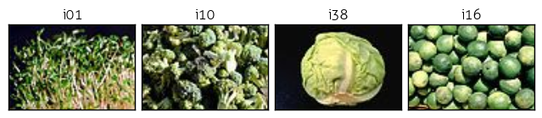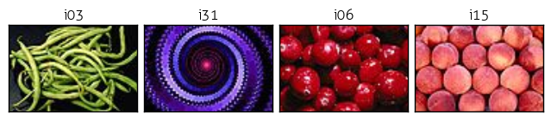

Good Results

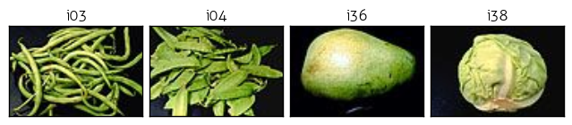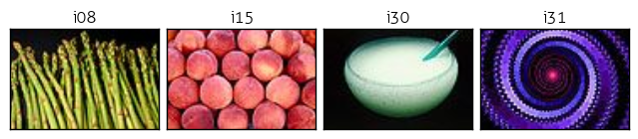

**def** find_four(chist_dis):

results = {}

*# ensure that a<b, b<c and c<d as order does not matter*

**for** a **in** xrange(NUM_IM):

**for** b **in** xrange(a+1,NUM_IM):

**for** c **in** xrange(b+1,NUM_IM):

**for** d **in** xrange(c+1,NUM_IM):

results[(a,b,c,d)] = \

chist_dis[(a,b)] + chist_dis[(a,c)] + \

chist_dis[(a,d)] + chist_dis[(b,c)] + \

chist_dis[(b,d)] + chist_dis[(c,d)]

results = sorted([(v, k) **for** (k, v) **in** results.items()])

best = results[0]

worst = results[-1]

indices = list(best[1])

indices.extend(list(worst[1]))

**return** indices

Creates 91390 entries

**def** color_matches(k, chist_dis):

*"""*

*Find images most like and unlike an image based on color distribution.*

*k -- the original image for comparison*

*chists -- the list of color histograms for analysis*

*"""*

results = {}

indices = []

distances = []

**for** i **in** xrange(0, NUM_IM):

**if** k > i: *# because tuples always begin with lower index*

results[i] = chist_dis[(i,k)]

**else**:

results[i] = chist_dis[(k,i)]

*# Ordered list of tuples (dist, idx) from most to least similar*

*# -- first value will be the original image with diff of 0*

results = sorted([(v, k) **for** (k, v) **in** results.items()])

*# print 'results for image', k, results*

seven = results[:4]

seven.extend(results[-3:])

*# print 'last seven for image', k, seven*

distances, indices = zip(*seven)

*# print 'distances:',distances*

*# print 'indices:',indices*

**return** indices, distances

## Full Results

### Image Septuples:

|  |  |  |  |  |  |  |
| --- | --- | --- | --- | --- | --- | --- |
| Original | Most Like | 2nd Most Like | 3rd Most Like | 3rd Most Unlike | 2nd Most Unlike | Most Unlike |

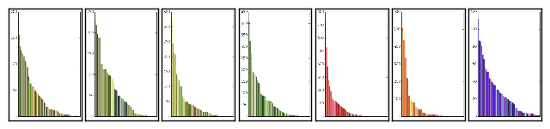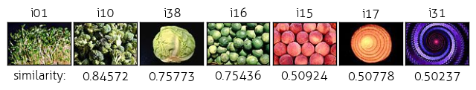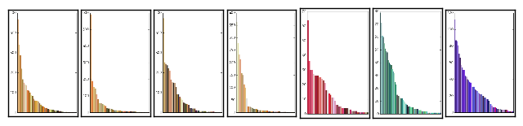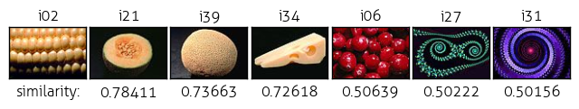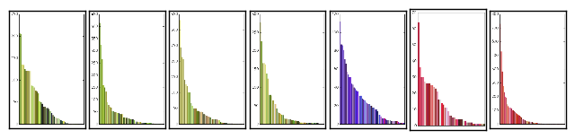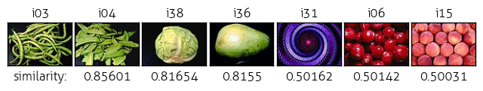

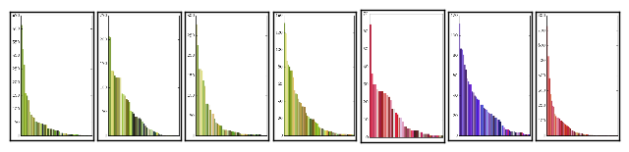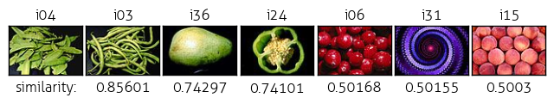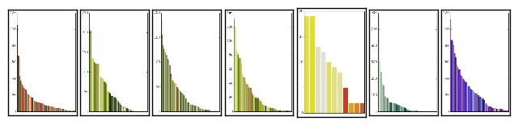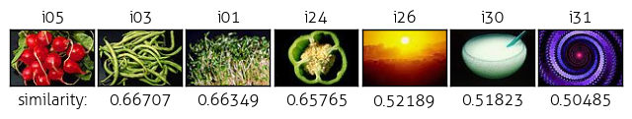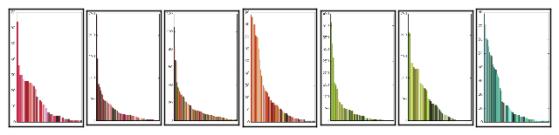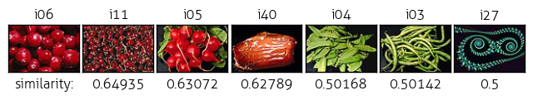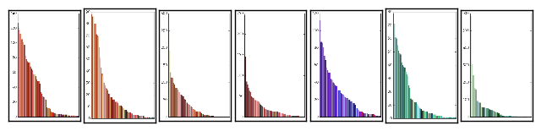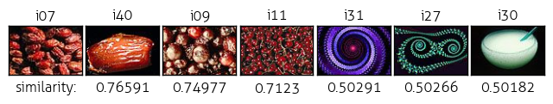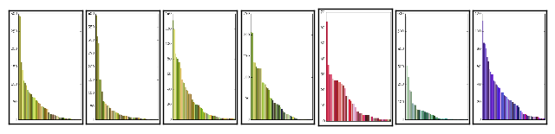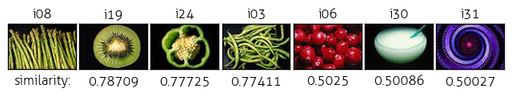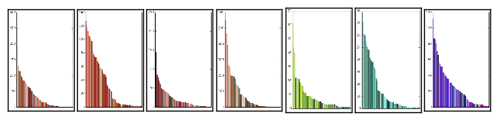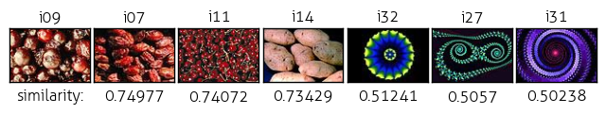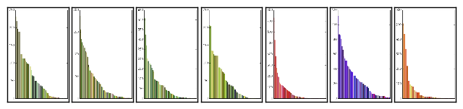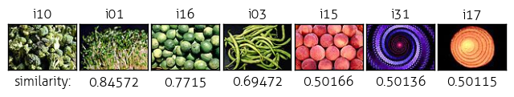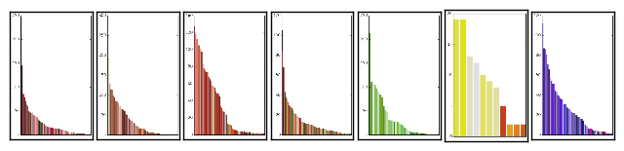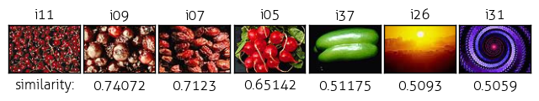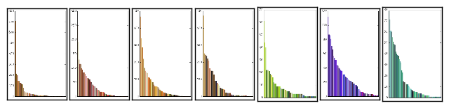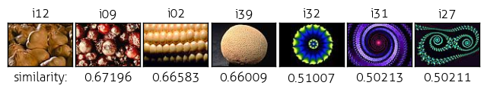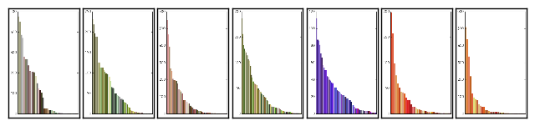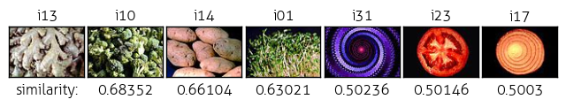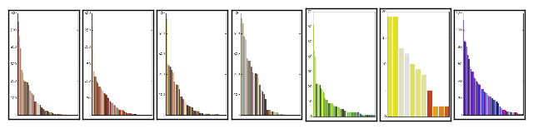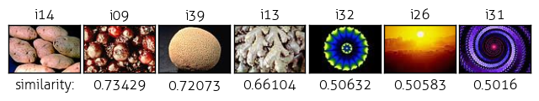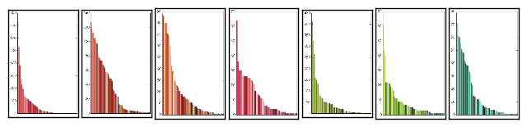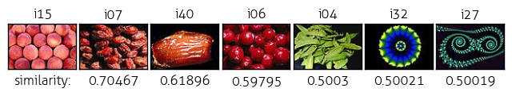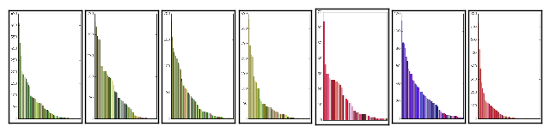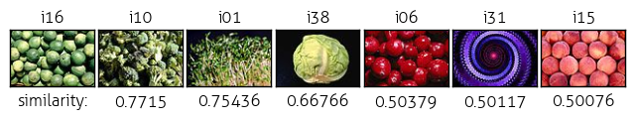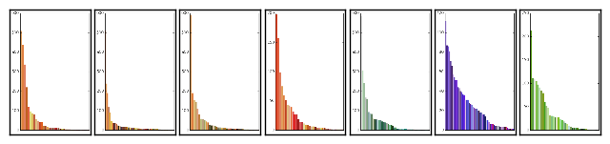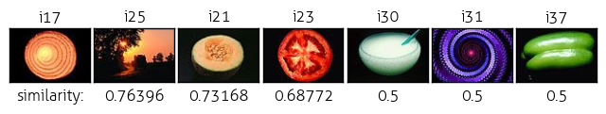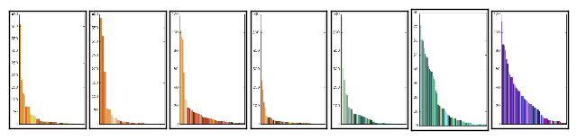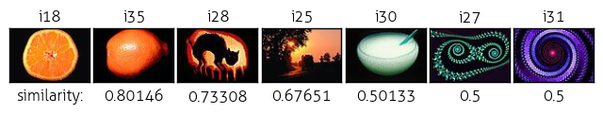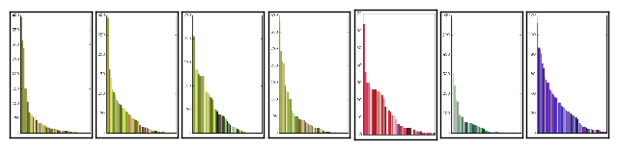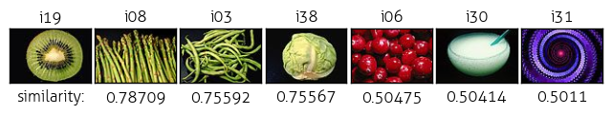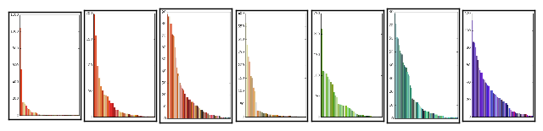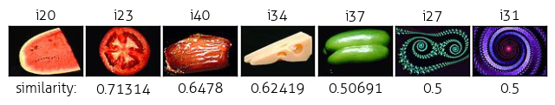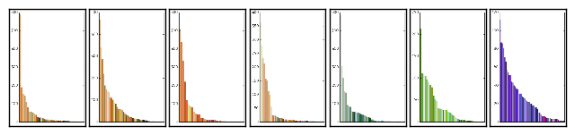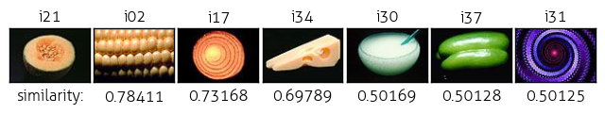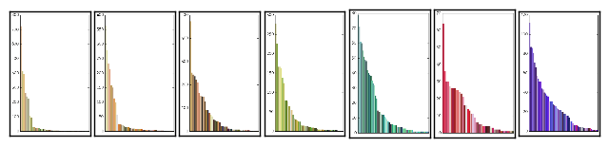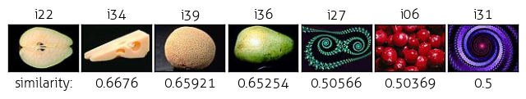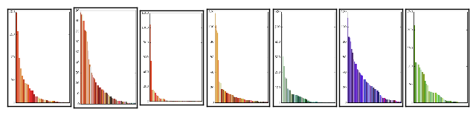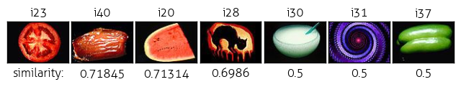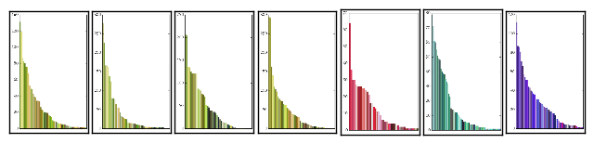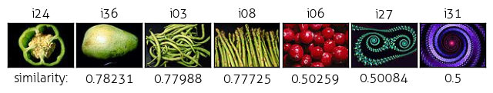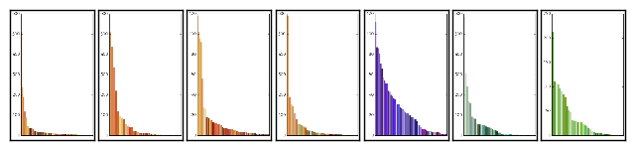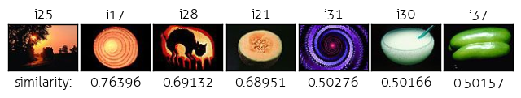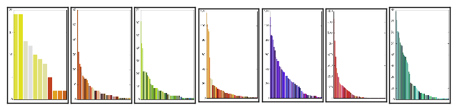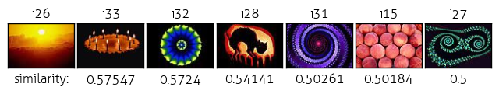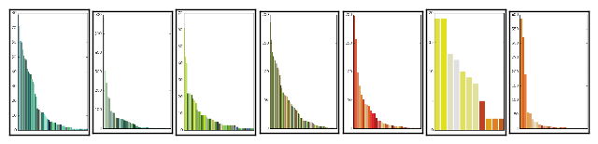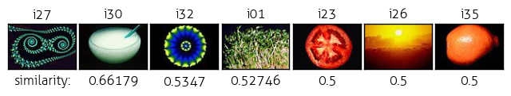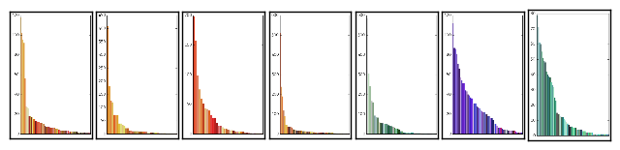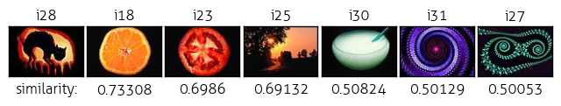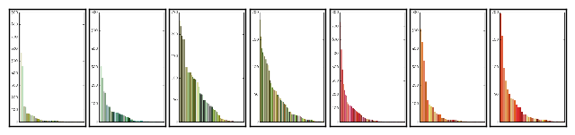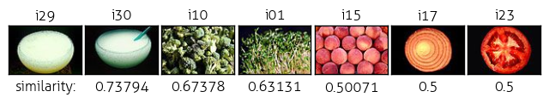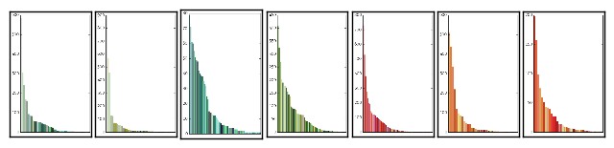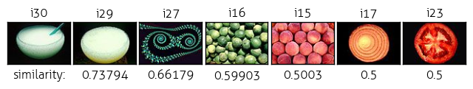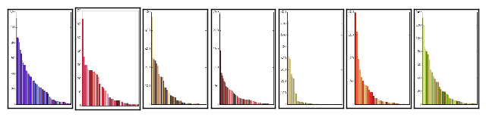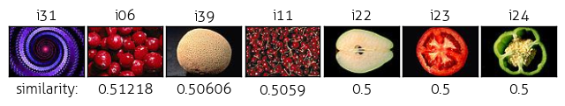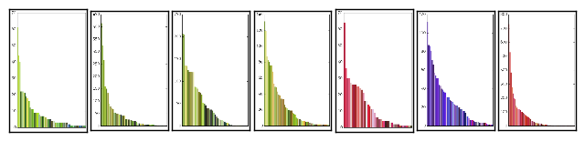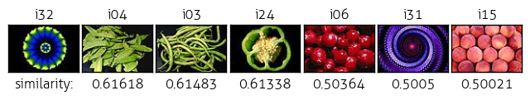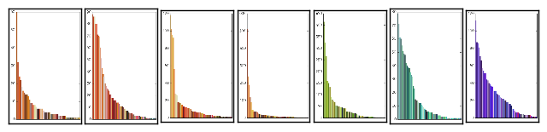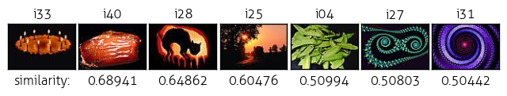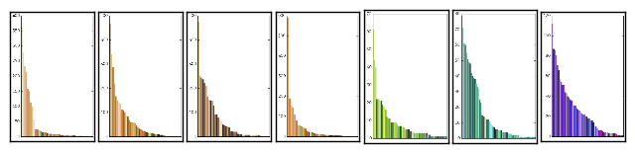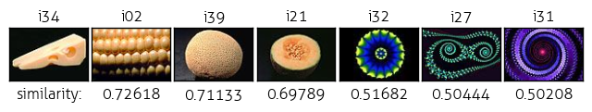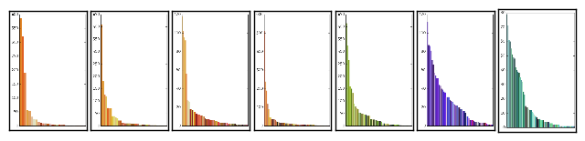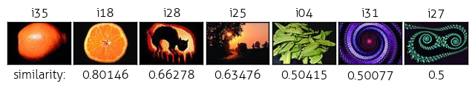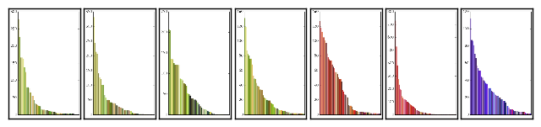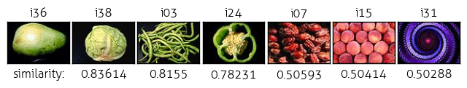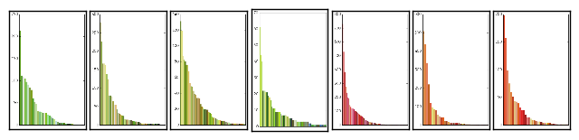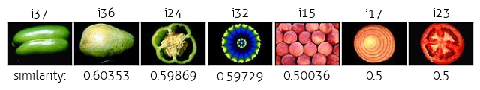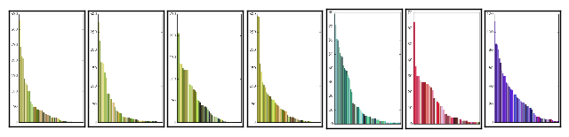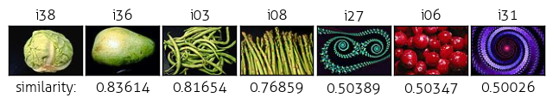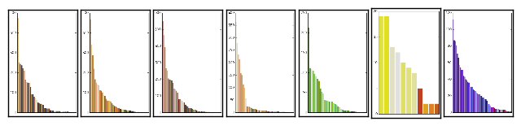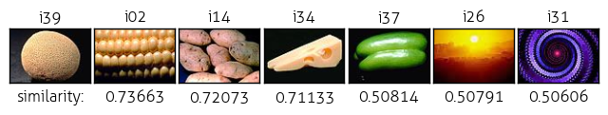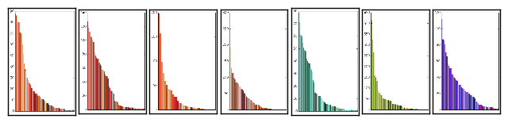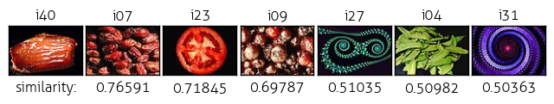

### Four Best Match:



### Four Worst Match:

## 

# Gross Texture Matching

## Texture Measure

* Very similar to color matching algorithm, with a few notable differences:
* Create 1D histogram based on Laplacian image, which is calculated for each pixel by multiplying that pixel’s value by the number of neighbors and subtracting the sum of its neighbors pixels
* This measures ‘edginess’ because range of 1s and 0s

## Bin Size and Black Threshold

|  |  |  |  |  |  |  |
| --- | --- | --- | --- | --- | --- | --- |
| (i-1,j-1) | (i-1,j) | (i-1,j+1) |  | Top left | Top center | Top right |
| (i,j-1) | (i,j) | (i,j+1) |  | Center right | Center | Center left |
| (i+1,j-1) | (i+1,j) | (i+1,j+1) |  | Bottom right | Bottom center | Bottom left |

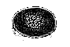

i21

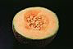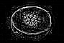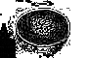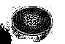

blk thresh: 0 15 20 40

* All the similarities between close pairs seemed very high, in the 90s
* Adjustments made: changed thresh, changed Laplacian bin size, still around that range

LAP_BINS = 128

LAP_BIN_SZ = int(COL_RANGE*8)/LAP_BINS

**def** grayscale(image, title):

*"""Convert image into black and white with (R+G+B)/3"""*

gray = np.zeros(shape=(IMG_H, IMG_W))

**for** row **in** xrange(IMG_H):

**for** col **in** xrange(IMG_W):

*# compose gray image pixel by pixel*

pixel = image[row][col]

rgb = int(pixel[0]) + int(pixel[1]) + int(pixel[2])

g = int(round((rgb / 3.0),0)) *# round up*

gray[row][col] = g

*# gray_img = cv2.imread(gray, cv2.IMREAD_UNCHANGED)*

cv2.imwrite('./gray/'+title+'.png', gray)

**return** gray

**def** laplacian(gray, title):

*"""Make laplacian image by calculating sum of neighbors for every pixel"""*

*# gray = grayscale(image)*

laplacian = np.zeros(shape=(IMG_H, IMG_W))

*# laplacian.fill(COL_RANGE) # white would be 255+255+255/3 = 255*

**for** i **in** xrange(0,IMG_H):

**for** j **in** xrange(0,IMG_W):

*# if gray[i][j] > int(BLK_THRESH/2):*

**if** gray[i][j]:

neighbors = []

**for** row **in** xrange(i-1,i+2):

**for** col **in** xrange(j-1,j+2):

**if** **not** (row **is** i **and** col **is** j) **and** index_valid(row,col):

neighbors.append(gray[row][col])

neighbor_sum = reduce(**lambda** x, y: x+y, neighbors)

n = len(neighbors)

laplacian[i][j] = gray[i][j]*n - neighbor_sum

*# print 'calculations per pixel:', laplacian[i][j], gray[i][j], n, neighbor_sum*

*# print 'laplacian',laplacian*

cv2.imwrite('./laplacian/'+title+'.png', laplacian)

**return** laplacian

**def** index_valid(row,col):

**if** (row < 0 **or** col < 0 **or** row >= IMG_H **or** col >= IMG_W):

**return** False

**return** True

**def** visualize_thist(image, hist, bins, title):

*# bins = sorted(bins, key=lambda c: -hist[c])*

plt.rcParams['font.family']='Aller Light'

**for** idx, c **in** enumerate(bins):

plt.subplot(1,2,1).bar(c, hist[c], color='#D3D3D3')

dir_name = './texture_hist/'

**if** **not** os.path.exists(dir_name):

os.makedirs(dir_name)

title = dir_name+title+'.png'

plt.savefig(title, bbox_inches='tight')

plt.clf()

plt.close('all')

**print** title

plot = cv2.imread(title, cv2.IMREAD_UNCHANGED)

**return** plot

*# show(plot, 100)*

*# clear image*

**def** texture_histogram(lap, gray, title):

hist = np.zeros(shape=LAP_BINS)

bins = []

**for** i **in** range(IMG_H):

**for** j **in** range(IMG_W):

pixel = lap[i][j]

*# Only count pixels outside the black threshold*

*# to avoid image similarity due to shared black background*

**if** gray[i][j] > BLK_THRESH:

**if** pixel < 256:

bin = abs(pixel/LAP_BIN_SZ)

hist[bin] += 1

**if** bin **not** **in** bins:

bins.append(bin)

*# plot = visualize_thist(gray, hist, bins, title)*

*# print 'hist', hist*

*# return hist, plot*

**return** hist

**def** l1_texture_norm(h1, h2):

diff = 0

total = 0

**for** bin **in** xrange(0,LAP_BINS):

diff += abs(h1[bin] - h2[bin])

total += h1[bin] + h2[bin]

l1_norm = diff / 2.0 / total

similarity = 1 - l1_norm

**return** l1_norm

**def** calc_tdistance(thists):

thist_dis = {}

**for** i **in** xrange(NUM_IM):

**for** j **in** xrange(i, NUM_IM):

**if** (i,j) **not** **in** thist_dis:

d = l1_texture_norm(thists[i], thists[j])

thist_dis[(i,j)] = d

**return** thist_dis

**def** texture_matches(k, thist_dis):

results = {}

indices = []

distances = []

**for** i **in** xrange(0, NUM_IM):

**if** k > i: *# because tuples always begin with lower index*

results[i] = thist_dis[(i,k)]

**else**:

results[i] = thist_dis[(k,i)]

results = sorted([(v, k) **for** (k, v) **in** results.items()])

seven = results[:4]

seven.extend(results[-3:])

distances, indices = zip(*seven)

**return** indices, distances

## Results

## 

## 

## 

## 

## 

## 

## 

## 

## 

## 

## 

## 

## 

## 

## 

## 

## 

## 

## 

## 

## 

## 

## 

## 

## 

## 

## 

## 

## 

## 

## 

## 

## 

## 

## 

## 

## 

## 

## 

## 

## 

## 

## 

## 

## 

## 

## 

## 

## 

## 

## 

## 

## 

## 

## 

## 

## 

## 

## 

## 

## 

## 

## 

## 

## 

## 

## 

## 

## 

## 

## 

## 

## 

## 

## 

## 

## 

## 

## 

## 

## 

## 

## 

## 

## 

## 

## 

## 

## 

## 

## 

## 

## 

## 

## 

## 

## 

## 

## 

## 

## 

## 

## 

## 

## 

## 

## 

## 

## 

## 

## 

## 

## 

## 

## 

## 

## 

## 

## 

## Combine Similarities, and Cluster

## Similarity Measure

**def** combine_similarities(chist_dis, thist_dis):

similarities = {}

distances = {}

closest = 1

r = 0.5

**for** i **in** xrange(NUM_IM):

**for** j **in** xrange(i+1, NUM_IM):

**if** (i,j) **not** **in** similarities:

t_sim = 1 - thist_dis[(i,j)]

c_sim = 1 - chist_dis[(i,j)]

s = r*(t_sim) + (1-r)*(c_sim)

d = 1 - s

*# d = r*thist_dis[(i,j)] + (1-r)*chist_dis[(i,j)]*

similarities[(i,j)] = s

distances[(i,j)] = d

*# if (d < closest):*

*# closest = (i,j)*

**return** similarities, distances*#, closest*

## Complete Link vs. Single Link Clustering

*# 0 is COMPLETE LINK, 1 is SINGLE*

**def** cluster(distances, link):

clusters = {}

**for** idx **in** xrange(0,NUM_IM):

clusters[(idx,)] = (idx,)

*# print clusters*

counter = 0

**while** len(clusters) > NUM_CLUSTERS:

nearest_pair = (None, None)

nearest_dist = 1 *# total dissimilarity*

counter += 1

*# Go through every cluster-pair to find nearest pair*

**for** a **in** clusters:

**for** b **in** clusters:

*# Do not compare with same cluster*

**if** a **is** **not** b:

dist = link

*# For each element in both clusters, determine "nearness"*

*# Complete nearness: farthest distance bt any 2 el in 2 clusters*

*# Single nearness: nearest distance bt any 2 el in 2 clusters*

**for** i **in** clusters[a]:

**for** j **in** clusters[b]:

k = (i,j)

**if** i > j:

k = (j,i) *# tuples always in ascending order*

curr_dist = distances[k]

**if** (link **is** 0 **and** curr_dist > dist) **or** \

(link **is** 1 **and** curr_dist < dist):

dist = curr_dist

*# Find out if this is the nearest pair so far in the iteration*

**if** dist < nearest_dist:

nearest_dist = dist

nearest_pair = (a,b)

nearest_pair_values = clusters[a]+clusters[b]

*# combine the nearest pair of clusters and remove old clusters*

clusters.pop(nearest_pair[0])

clusters.pop(nearest_pair[1])

*# new_pair = nearest_pair[0] + nearest_pair[1]*

clusters[nearest_pair_values] = nearest_pair_values

*# clusters[new_pair] = clusters[new_pair]*

**print** counter, clusters.keys()

*# print clusters*

clusters = clusters.keys()

**return** clusters

1 : New distance for (2,) (3,) 0 -> 0.4

1 : Replace distance with ((2,), (3,)) 1000 -> 0.4

1 : New distance for (2,) (1,) 0 -> 0.5

1 : New distance for (2,) (4,) 0 -> 0.6

1 : New distance for (3,) (2,) 0 -> 0.4

1 : New distance for (3,) (1,) 0 -> 0.1

1 : Replace distance with ((3,), (1,)) 0.4 -> 0.1

1 : New distance for (3,) (4,) 0 -> 0.3

1 : New distance for (1,) (2,) 0 -> 0.5

1 : New distance for (1,) (3,) 0 -> 0.1

1 : New distance for (1,) (4,) 0 -> 0.2

1 : New distance for (4,) (2,) 0 -> 0.6

1 : New distance for (4,) (3,) 0 -> 0.3

1 : New distance for (4,) (1,) 0 -> 0.2

1 [(2,), (3, 1), (4,)]

2 : New distance for (2,) (3, 1) 0 -> 0.4

2 : New distance for (2,) (3, 1) 0.4 -> 0.5

2 : Replace distance with ((2,), (3, 1)) 1000 -> 0.5

2 : New distance for (2,) (4,) 0 -> 0.6

2 : New distance for (3, 1) (2,) 0 -> 0.4

2 : New distance for (3, 1) (2,) 0.4 -> 0.5

2 : New distance for (3, 1) (4,) 0 -> 0.3

2 : Replace distance with ((3, 1), (4,)) 0.5 -> 0.3

2 : New distance for (4,) (2,) 0 -> 0.6

2 : New distance for (4,) (3, 1) 0 -> 0.3

2 [(2,), (3, 1, 4)]

3 : New distance for (2,) (3, 1, 4) 0 -> 0.4

3 : New distance for (2,) (3, 1, 4) 0.4 -> 0.5

3 : New distance for (2,) (3, 1, 4) 0.5 -> 0.6

3 : Replace distance with ((2,), (3, 1, 4)) 1000 -> 0.6

3 : New distance for (3, 1, 4) (2,) 0 -> 0.4

3 : New distance for (3, 1, 4) (2,) 0.4 -> 0.5

3 : New distance for (3, 1, 4) (2,) 0.5 -> 0.6

3 [(2, 3, 1, 4)]

[(2, 3, 1, 4)]

## Results

# Creative Step

## Performance Measure

## Friend Results

## System Results

# Code Listing

## visret.py

## performance.py

# Appendix: User Studies

